This is an example title for your work (Please use Arial 14, bold)
Failure to comply may result in rejection of the abstract!
Please find an exemplary abstract on the next page.
Please delete this text box.
Please send your abstract to fjs-abstracts@jcf.io
First author,¹ presenting author (underlined),¹ third author,² etc. (Arial 12)
¹ State your affiliations after a superscript and a space, centered with the following pattern (Arial 12, italic, centered)
² University, Institute, City, Country
Your abstract should appear here. Please use Arial 12, justified with a 1.15 line spacing. The margins are 2 cm to the left and right, and 2.5 cm to the top and bottom. If you want to use equations, please stick to Arial 12 and number them in the same way, with the number on the right and in brackets – feel free to use the following table of equation (1). Please use an appropriate spacing to the rest of the text.
 | E = mc² | (1)
We allow one figure in your abstract which should be referenced as Fig./Scheme/Table 1. Please use the Microsoft Word caption tool to add the description (right-click on the image 🡪 insert caption) and use appropriate spacing to the text.
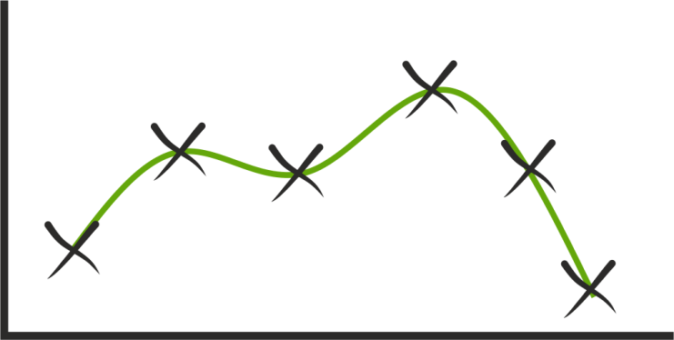
Figure 1: Description of the figure. (Arial 10, centered)
Please add your references manually in the Angewandte Chemie style. In the text, they should appear as a superscript,^{[1]} appearing without space after punctuation. Depending on the number of references, they should be connected with an en dash (–)^{[1–3]} or separated with a comma without additional spacing in between.^{[1,2,4]} Refer to those in a list at the end of your document. Please keep to our limit of one page per abstract.
References: (Arial 12, bold)
[1] A. Surname, B. Surname, Journal Abbreviation Year, edition, page–page.(Arial 12, justified)
[2] C. D. Surname, E. Surname, F. Surname, J. Abbr. Year, edition, eLocator.
[3] G. Surname, G. H. Surname, I. Surname, J. K. Surname, Abbr. Journ. Year, edition, page–page.
[4] L. Surname, J. Abbr. Year, edition, eLocator.
Exemplary Abstract – How it should look like
Erika K. Mustermann,¹ Jane A. Smith,² Michael Müller¹
¹ Ulm University, Institute of Fictional Chemistry, Ulm, Germany
² University of Stuttgart, Institute of Imagination, Stuttgart, Germany
Lorem ipsum dolor sit amet, consectetur adipiscing elit, sed do eiusmod tempor incididunt ut labore et dolore magna aliqua. Ut enim ad minim veniam, quis nostrud exercitation ullamco laboris nisi ut aliquip ex ea commodo consequat.^{[1]} Duis aute irure dolor in reprehenderit in voluptate velit esse cillum dolore eu fugiat nulla pariatur. Excepteur sint occaecat cupidatat non proident, sunt in culpa qui officia deserunt mollit anim id est laborum.^{[2]}
Lorem ipsum dolor sit amet, consectetur adipiscing elit,^{[3]} sed do eiusmod tempor incididunt ut labore et dolore magna aliqua.^{[4]} Ut enim ad minim veniam, quis nostrud exercitation ullamco laboris nisi ut aliquip ex ea commodo consequat.
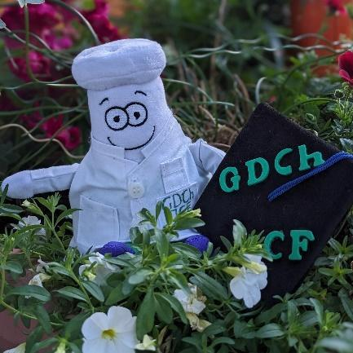
Figure 1: Science Erli, the mascot of JCF Team Science & Education.
Lorem ipsum dolor sit amet, consectetur adipiscing elit, sed do eiusmod tempor incididunt ut labore et dolore magna aliqua.^{[2–4]} Ut enim ad minim veniam, quis nostrud exercitation ullamco laboris nisi ut aliquip ex ea commodo consequat.^{[1–3,5]} Duis aute irure dolor in reprehenderit in voluptate velit esse cillum dolore eu fugiat nulla pariatur. Excepteur sint occaecat cupidatat non proident, sunt in culpa qui officia deserunt mollit anim id est laborum.^{[1,2,4,5]}
References:
[1] E. K. Mustermann, J. A. Smith, M. Müller, Angew. Chem. Int. Ed. 2007, 46, 999990–999999.
[2] C. Surname, D. Surname, E. Surname, Angew. Chem. Int. Ed. 2023, 62, e202309999.
[3] F. Surname, G. Surname, H. Surname, Chem. – Eur. J. 2022, 28, e202209999.
[4] I. Surname, J. Surname, K. L. Surname, Angew. Chem. Int. Ed. 2022, 61, e202209999.
[5] M. Surname, N. Surname, O. P. Surname, Q. Surname, Angew. Chem. Int. Ed. 2020, 59, 999990–999999.

